 | Title : Project Registration & Progress Review |  | FF No. 180
Department: Computer Engineering |  | Academic Year: 2026-2027
Semester : 07 |  | Group No. : 28
Project Title: AutoForensic Al: An Al Powered Car Damage Assessment System
Project Area: Computer Vision, Al, Cybersecurity & Digital Media Forensic
Group Members Details:

Sr. No. | Class & Div. | Roll No. | G.R.No. | Name of Student | Contact No. | Email ID
1 | BTech | 112 | 12310769 | Pranit Kothari | 9172887506 | pranit.kothari.23@vit.edu
2 | BTech | 198 | 12311463 | Siddhant Devsale | 8669024432 | siddhant.devsale231@vit.edu
3 | BTech | 199 | 12311333 | Mangesh Devikar | 7796329545 | mangesh.devikar231@vit.edu
4 | BTech | 184 | 12310469 | Vedant Gaikwad | 7620544089 | vedant.gaikwad23@vit.edu

Name of Internal Guide: Dr. Vikas Kolekar
Contact No. & Email ID: 8055822246 & vikas.kolekar@vit.edu

Project approved / Not approved

Dr. Vikas Kolekar Dr. Ranjeetsingh Suryawanshi Prof.(Dr.) S.R.Shinde
Guide Project Coordinator Head,
Department of Computer Engineering

T
FF No 180

Project Synopsis

Introduction
Vehicle damage assessment is traditionally performed through manual inspection, which can be time-consuming, subjective, and difficult to scale for large numbers of insurance claims. Existing computer vision systems can detect vehicle damage, but many approaches primarily focus on 2D detection and do not consider image authenticity, damage severity, physical dimensions, or automated repair-cost estimation.
AutoForensic AI introduces an end-to-end AI-powered vehicle damage assessment framework that combines computer vision, digital media forensics, monocular depth estimation, cybersecurity, and automated cost reasoning. The system first validates uploaded vehicle images for authenticity and duplicate submissions, then uses a fine-tuned YOLOv8-Seg model to segment damage such as scratches, dents, and cracks. Monocular depth estimation is used to obtain additional severity information, while an inference-based cost engine generates an itemized repair-cost estimate. A digitally generated assessment report is secured using SHA-256 hashing to maintain report integrity.

Project Title
AutoForensic AI: An AI-Powered Car Damage Assessment System

Project Description
AutoForensic and Al is a cloud-based enterprise platform that automates vehicle damage assessment engineering. prevents insurance fraud by unifying cybersecurity, computer vision, and full-stack cloud metadata, and The duplicate system proactively screens uploaded media for digital tampering, fake then submissions before any visual analysis begins. Authentic images are masks, processed while using a YOLOv8-Seg neural network to precisely outline damages with polygon these precise monocular depth models estimate the physical depth and surface area. Based on generates a certified visual metrics, the platform automatically calculates itemized repair costs and final PDF assessment report, which is secured with an immutable SHA-256 cryptographic hash to guarantee absolute data integrity.

Problem Statement
Traditional vehicle damage inspections are slow and manual workflows, costing the global insurance industry billions annually in administrative overhead and "claims leakage". While academic computer vision models can detect car damage. they blindly trust input images, leaving organizations highly vulnerable to digital fraud via manipulated photos or Al-generated synthetic damage. Furthermore, standard Al models only draw flat 2D bounding boxes around damage, failing to calculate the physical surface area or depth dimensions required for accurate repair pricing. There is a critical need for an end-to-end, production-ready system that integrates computer vision into a secure, scalable, full-stack cloud environment with built-in fraud defenses.

Project Objectives
- Implement Media Forensics: Validate image authenticity using Error Level Analysis (ELA), EXIF metadata checks, and perceptual hashing to identify duplicate or digitally manipulated photos.
- Deploy Instance Segmentation: Utilize a fine-tuned YOLOv8-Seg model to accurately outline the exact boundaries of vehicle exterior damages (such as scratches, dents, and cracks) using sub-pixel polygon masks.
- Calculate Volumetric Severity: Integrate monocular depth estimation models to measure the physical depth and real-world surface area ($cm^2Pof the damage, moving beyond simple 2D coordinates.
- Automate Repair Cost Reasoning: Build an inference rule engine that calculates itemized parts and labor costs automatically based on the Al's spatial and categorical findings.

System Architecture

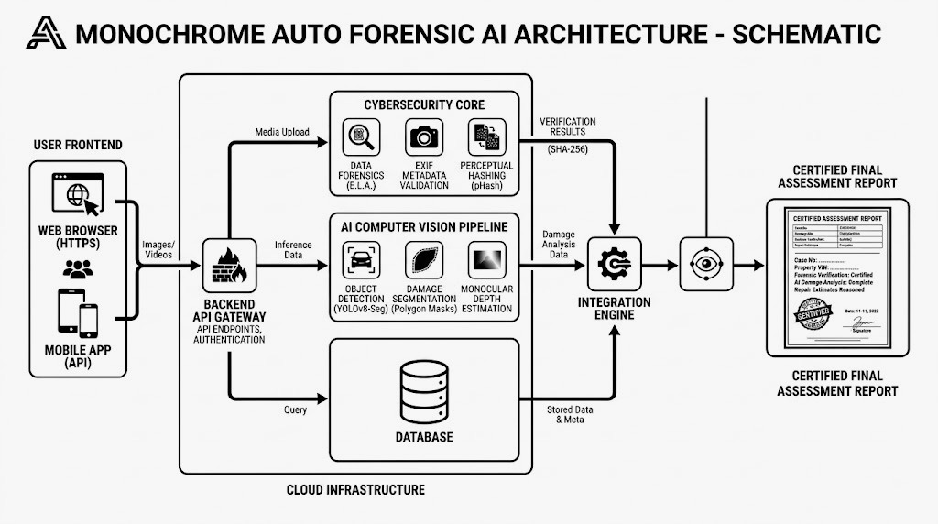

Environment
The system reduces environmental impact by replacing a portion of traditional physical inspection and documentation processes with digital image-based assessment. AI-based preliminary assessment can reduce unnecessary inspection activities, physical travel, paper-based documentation, and repeated assessments.
The use of optimized AI models and early validation of uploaded media can also reduce unnecessary computation by preventing invalid or duplicate images from entering the complete AI processing pipeline.

Example
If invalid, manipulated, or duplicate vehicle images are identified before entering the complete computer vision pipeline, unnecessary AI processing can be avoided. An optimized AutoForensic AI pipeline can reduce:
- CPU/GPU utilization.
- AI inference time.
- Cloud computing and storage requirements.
- Energy consumption.

Environmental Comparison

Metric | Conventional Assessment | AutoForensic AI
Physical inspection | Required for preliminary assessment | Reduced for preliminary assessment
Documentation | Paper/manual + digital | Primarily digital
Image processing | Manual inspection | Automated AI processing
Duplicate image checking | Manual
  Automated perceptual hashing
AI computation | Not applicable | Optimized inference pipeline

Sustainability
- Technical Sustainability: The modular architecture allows individual components such as the segmentation model, depth-estimation model, forensic modules, cost engine, and database services to be updated without redesigning the complete system.
- Operational Sustainability: The system can process digital assessments repeatedly and maintain structured assessment records, reducing dependency on repetitive manual workflows.
- Maintainability & Extensibility: New damage categories, vehicle models, datasets, AI models, and cost rules can be incorporated through modular components.
- Model Sustainability: AI models can be retrained using new and appropriately validated datasets to improve performance as additional damage examples become available.
- Scalability: The cloud-based architecture can be scaled to support increasing numbers of users, vehicles, images, and assessment requests.

Safety and Security
- Confidence-Based Prediction: AI predictions should include confidence information to identify uncertain results.
- Human Verification: Low-confidence or safety-critical damage should be referred for manual inspection.
- Critical Damage Detection: The system should identify potentially serious damage and generate appropriate warnings.

Reference Example for Environment, Sustainability, Safety, Ethics, Cost:

Environment:
The project considers environmental sustainability by optimizing AI models, reducing computational requirements, and enabling digital vehicle damage assessment that can reduce unnecessary physical inspection activities.

Example
If a lightweight model provides comparable accuracy to a much larger model, the lightweight model can reduce:
- CPU/GPU utilization.
- Inference time.
- Cloud computing cost.
- Energy consumption.
Parameter | Existing Model | Proposed Model
Model size | 120 MB | 35 MB
Inference time | 450 ms | 180 ms
Memory usage | 1.2 GB | 650 MB
Accuracy | 92% | 91%
Student should include Actual project results in their final report.

Sustainability :
Sustainability should address both technical sustainability and operational sustainability. AutoForensic AI is designed as a modular and scalable system that can accommodate new vehicle models, damage categories, datasets and AI algorithms, thereby supporting long-term technical sustainability.

AutoForensic Project-specific considerations : The system should be
- Modular.
- Maintainable.
- Scalable.
- Upgradeable.
- Capable of incorporating new damage categories.
- Capable of retraining with new datasets.
- Compatible with future AI models.
- Deployable on cloud or edge devices.

Example
The system initially recognizes: Scratch → Dent → Crack
Later, new categories can be added:
Rust → Broken Glass → Paint Damage → Headlight Damage
without redesigning the complete application.
Student should submit following things in their final project report for Sustainability
- Modular architecture.
- Database design.
- Scalability analysis report.
- Version controlled code.
- Model versioning.
Safety and Security:
The project incorporates safety and cybersecurity considerations by providing confidence-based predictions, identifying potentially critical damage, supporting human verification for uncertain cases, validating uploaded files, and protecting vehicle and customer data.

AutoForensic Project-specific Safety considerations
- Accurate damage detection.
- Avoiding false negatives for critical damage.
- Identification of safety-critical components.
- Confidence score for predictions.
- Human verification for uncertain predictions.
- Appropriate warning for severe damage.
- Avoiding automated recommendation when confidence is below a threshold.
Example
If the AI identifies Possible structural damage is 62% then the system should recommend that Manual inspection required rather than automatically declaring the vehicle safe.
Cybersecurity : Project should also address
- Secure image upload.
- Authentication.
- Authorization.
- Secure APIs.
- Database security.
- Encryption.
- Protection against malicious file uploads.
- Secure storage of vehicle/customer information.
Student should include Safety and Security Test report in their final project report.
Ethical Considerations:
The project addresses ethical AI considerations including privacy, consent, dataset bias, responsible use of AI predictions, transparency, explainability, intellectual property, and human verification of AI-generated assessments. Ethics is very important for AutoForensic AI because the system may process images, insurance-related information and potentially personal data.
Important considerations
Data Privacy : Images may contain Vehicle registration numbers, Owners, Locations, Personal information. Therefore Data collection should have appropriate consent.
- Sensitive information should be protected.
- Images should be securely stored.
- Data retention should be defined.
Students should include data privacy declaration in their final report.

Cost and Economic Feasibility :
The economic feasibility of AutoForensic AI is evaluated by comparing development and operational costs with potential reductions in inspection time, manual effort, and preliminary assessment costs.
AutoForensic AI has significant potential for cost reduction in preliminary vehicle damage assessment.

Cost factors
- Dataset acquisition.
- GPU/model training.
- Cloud infrastructure.
- Application development.
- Database.
- API services.
- Hosting.
- Maintenance.
- Model retraining.

Potential economic benefits : The system can potentially reduce
- Initial inspection time.
- Manual assessment effort.
- Repeated inspection.
- Documentation effort.
- Preliminary claim-processing time.
Conventional Manual Assessment chart
Parameter | Manual Method
Assessments/month | 500
Average inspection time | 30 minutes/vehicle
Total inspection time | 250 hours/month
Approx. assessor cost | ₹300/hour
Monthly assessment cost | ₹75,000
Report preparation | Manual

Students should include cost Assessment chart in their final project report.

FF No 180

Group No.
Activity | Review Schedule | Progress Review Report submitted | Signature of Guide
Review 1 | Mid Sem. Semester | Yes / No
Review 2 | End of Semester | Yes / No

Format of Progress Review Report:

Review No.: 1 Group No.: Date:

Progress Review Report

Signature of Guide:

Review No.: 2 Group No.: Date:

Progress Review Report

Signature of Guide:

